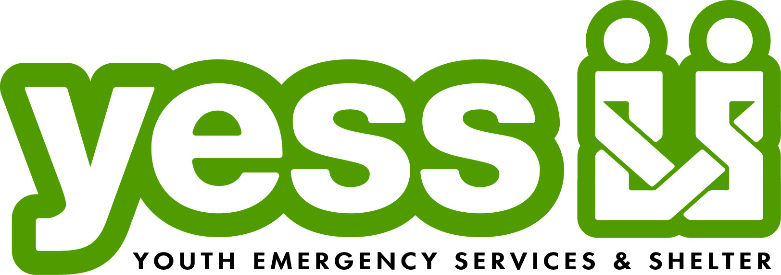

**CONTACT INFO WEBSITES**

Kristin Huinker, Development Manager www.yessiowa.org

huinkerk@yessiowa.org www.yessduckderby.org

Phone: (641) 420-3194 (cell)

**THE AGENCY**

From its inception in 1973 as a runaway shelter, YESS has grown into a well-established child welfare agency, providing emergency shelter, crisis care, and counseling services for 1,000 children each year, newborn to age 17.

The agency’s signature fundraising event, the YESS Duck Derby, provides the ultimate opportunity for community and volunteer engagement. Each spring, the community is invited to “Adopt a Duck” for $5 and cheer on their little fowl friend on Race Day (always the first Saturday in May). The first 10 “Lucky Ducks” to cross the finish line win great prizes, and friends of all ages can enjoy free family-friendly activities, local entertainment, food samples from area restaurants, sponsor booths, and more. The 2014 YESS Duck Derby was a “splashing” success, racing nearly 35,000 rubber ducks, bringing together 7,000 friends of YESS, and generating nearly $300,000 to support the agency and the youth we serve.

**THE PROBLEM**

Each year, the Duck Derby builds an unbelievable amount of energy and excitement, providing YESS with a year-round platform to advocate on behalf of vulnerable youth in our community. However, YESS struggles to capture and engage the untapped human and social capital potential of the thousands of Duck Derby donors, volunteers, and Race Day attendees.

**Key Takeaway: How do we engage users the other nine months of the year and connect them to the impact of their gift?**

**THE PROJECT**

Our idea is to create a Duck Derby mobile app/game that encourages year-round donor and volunteer engagement with YESS and its mission to keep kids safe. We want this game to embody the feel of the Duck Derby…the fun, the smiles, and the quackiness!

We’ve jotted down a few ideas below, but they are by no means intended to limit the flow of innovative ideas and input from the team.

Random thoughts…

* Duck race along a river (with obstacles?), memory game, maze
* Variations of the app framework to match special holidays/seasons (i.e. Christmas, fall, etc.)
* Encourage competitiveness or a reason to play again (trophy, high score, levels, etc.)
* Trivia about YESS and agency services
* 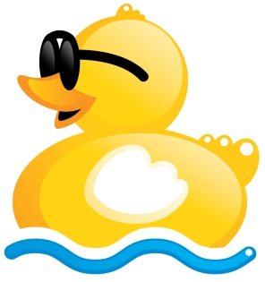Ability to develop and integrate into a much larger Duck Derby mobile website (social media sharing, calendar of events, volunteer link, etc.)